|  |
| --- |
|  |

To begin looking at the Spanish speaking world, and how the Spanish language came to the Americas, it is important to know and recognize the countries by their Spanish names. Using the maps in the book, complete the following.

1. Label each country with its name and capital city (in Spanish).
2. Locate the following mountain ranges and label them.
   1. Sierra Madre Occidental
   2. Sierra Madre Oriental
   3. Las Montañas Andes
3. Locate and label these bodies of Water
   1. El Mar Caribe
   2. El Golfo de México
   3. El océano Pacífico
   4. El Océano Atlántico
4. Color each country that Speaks Spanish with a different color. Countries next to each other should not be the same color.
5. Color all countries that are NOT Spanish speaking either green or brown.

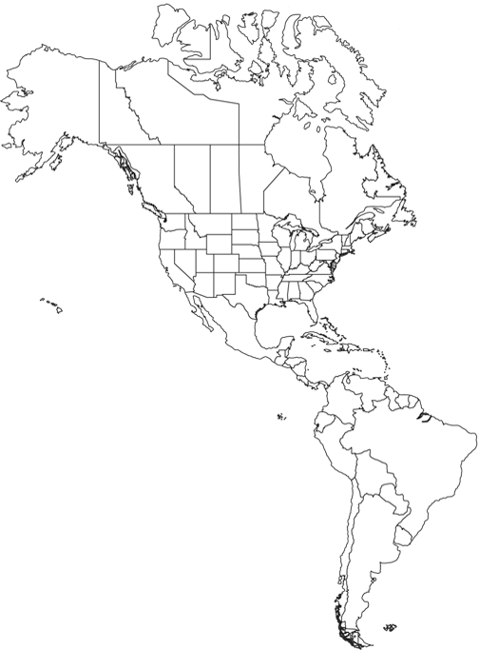

MC900183642[1]

_______________, los Estados Unidos

_______________,

**clipart provided by:** [**www.worldatlas.com**](http://www.worldatlas.com)